Rahul Garg  Oracle FAH Consultant  (PMP and Oracle Accounting Hub Cloud certified)  Phone : India : +91 9599474101  E-Mail : igargrahul@gmail.com | 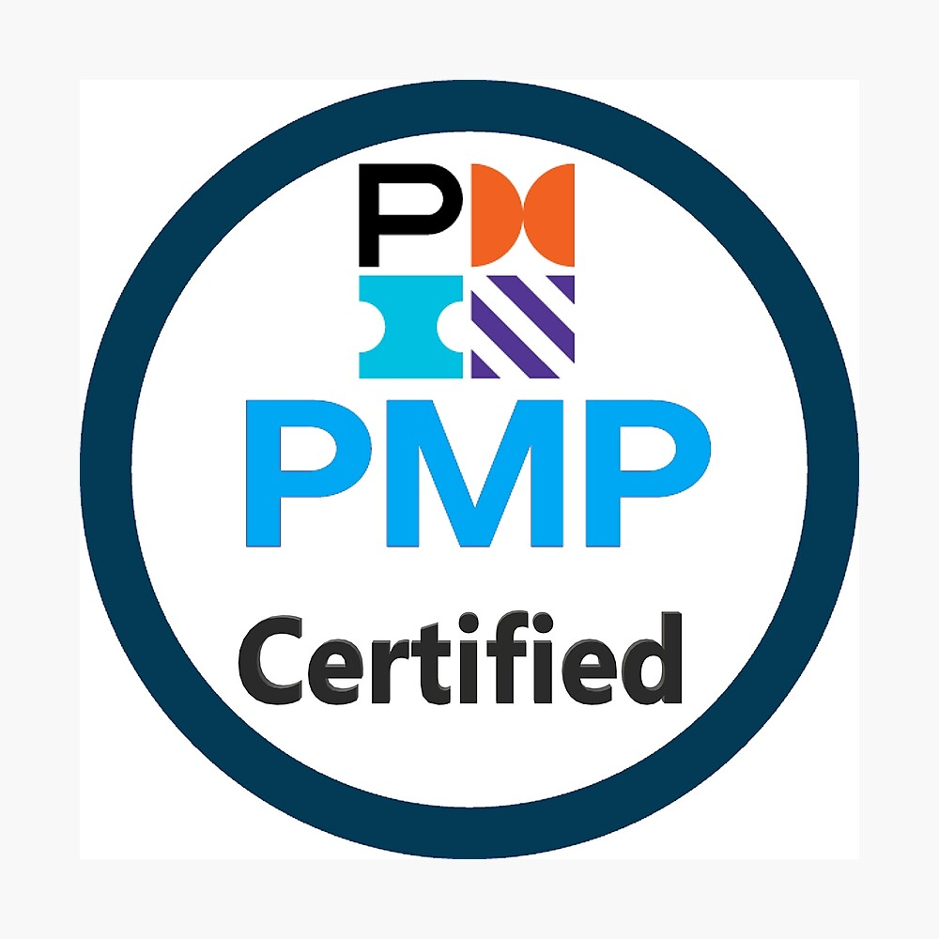

PROFESSIONAL SYNOPSIS
- A dynamic professional having 14 years of total experience in Oracle Financials including 8.5 years in Oracle Accounting Hub (FAH)

- Excellent practical knowledge of Fusion/Financials Accounting Hub (AHCS / FAH), Accounts Payable, Payments and General Ledger (including SLA) modules.

- Responsible for Project requirement gathering and working directly with Business Stakeholders throughout the development life cycle

- Good functional experience in Record to Report (R2R) and Procure to Pay (P2P) business cycles.

- Knowledge on Account Payables, Purchasing, iProcurement and Cash Management modules.
- Worked on preparation of Functional Design Documents (MD50, BR100), Reviewing Business Objectives and Functional Testing.

- Versed with Oracle E- Business Suite R12 and Oracle Cloud

- High Quality Experience in handling ERP Production Support, Review Trouble Tickets & Resolution, Month End Period Closing Activities and Enhancement changes.

- Good knowledge and experience in the use of Project Management methodologies and tools including Microsoft Project, Visio, Excel, and Word

- SPOC for quick response to business users, requirement gathering, providing status update to client.

- Acted as mentor for new joiners and responsible for their quick knowledge acquisition.

- Excellent verbal and written communication skills

- A proactive team player with ability to quickly grasp business requirements.

TECHNICAL SKILLS
Oracle Financials R12(12.1.3/12.2.4)/Oracle Fusion | Proficient: GL, SLA, AP, Payments and AHCS/FAH modules  Knowledge: AP, Purchasing, iProcurement and Cash Management modules
Languages | SQL
Oracle Tools | Toad, Data loader
Other Tools | Microsoft Project/Excel/Visio/Word, HPQC

CERTIFICATIONS
Name | Issued Date | Attachment
Project Management Professional (PMP) | 29-Dec-2020
Oracle Accounting Hub Cloud 2022 Implementation Professional | 07-Jul-2023

EXPERIENCE SUMMARY
Organization | Designation | Location | Duration
AtoS | Senior Software Engineer | Pune/  Mumbai | Jun’10 – Mar’14
Infogain | Senior Software Engineer | Pune | Mar’14 – Dec’14
IBM | Solution Consultant | Gurgaon | Dec’14 – Aug’16
XL India | Deputy Manager | Gurgaon | Sep’16 – Jun’23
KPMG | Manager | Gurgaon | Sep’23 – Apr’24
Infosys | Lead Consultant | Noida | Jun’24 – Jan’25

QUALIFICATIONS
Course | College/Board | Year of passing | Percentage/Grade
Executive MBA (EPYM - Finance) | IIM Calcutta | 2015-2016 | Good
B.E. | PICT, University of Pune | 2010 | 62.4

ORGANISATIONAL EXPERIENCE

With Infosys India, From Jun’24 – Jan’25, Location- Noida, India/Shah Alam, Malaysia
Projects Handled
- Project | : | Ichor Systems
Modules | : | Oracle Fusion Account Payables, Payments, Subledger Accounting (SLA), General Ledger
Duration | : | Jun’24 – Jan’25

Description:
Ichor is the leader in the design, engineering and manufacturing of critical fluid delivery subsystems and components for semiconductor capital equipment.

The project consisted of implementation of Oracle Fusion Financial modules for Ichor Malaysia and Singapore and Host to Host Payment Integration with Bank of America

Role & Responsibilities:

- Worked as Oracle Fusion Financials lead handling the design of Oracle Fusion GL, AP, Payments, and SLA modules

- Responsible for configuration of all the GL, AP, SLA related setups, coordination with business users, preparation of Functional documents and Functional testing.

- Responsible for the complete Host to Host integration with Bank of America for the Oracle Fusion Payments including the complete Fusion Payments configuration for Malaysia, Singapore Payment Files for Bank of America

With KPMG India, From Sep’23 – Apr’24, Location- Gurgaon, India
Projects Handled
- Project | : | Bank of Ayudhya (BAY)
Modules | : | Oracle Fusion Accounting Hub, General Ledger
Duration | : | Sep’23 – Nov’23

Description:
Bank of Ayudhya commonly referred to as Krungsri is the fifth largest bank in Thailand in terms of assets, loans, and deposits.
The project consisted of integration of Bank source systems to Fusion GL via AFCS and AHCS

Role & Responsibilities:

- Worked as Oracle Fusion Accounting Hub lead and presented the demo to the client for the end-to-end AFCS - AHCS - GL integration process

- Configured the complete Fusion Accounting Hub and GL setups for both Event based and Passthrough transactions required for the demo.

- Responsible for the complete integration and mapping design with AFCS module (Accounting Foundation Cloud Service) required for the demo
- Project | : | Emarat
Modules | : | Oracle Fusion General Ledger
Duration | : | Nov’23 – Apr’24

Description:
Emirates General Petroleum Corporation (Emarat) is a fuel services company that comprises commercial fuel and petrol products, terminalling and distribution facilities and a highly customer-oriented network of service stations.

The project consisted of implementation of all Oracle Fusion Financial modules

Role & Responsibilities:

- Working as functional analyst, handling the design of Oracle Fusion GL module

- Responsible for configuration of all the GL related setups, coordination with business users, preparation of Functional documents and Functional testing.

With XL India, From Sep’16 – Jun’23, Location- Gurgaon, India
Projects Handled
Project | : | Source To Post
Modules | : | Oracle Accounting Hub, General Ledger
Duration | : | Sep’16 – Jun’23

Description:
XL Group Ltd, through its subsidiaries and under the Axa XL brand, is a global insurance and reinsurance company providing property, casualty and specialty products to industrial, commercial, and professional firms, insurance companies and other enterprises throughout the world.

The project consists of integration of various source systems with GL module through Oracle Accounting Hub.

Role & Responsibilities:

- Worked as a functional analyst for Oracle GL & Accounting Hub modules, leading project team in all implementation & enhancement activities

- Responsible for the design & development of various business processes viz. FAH Posting Rules, Manual Adjustment Process including business requirement gathering, preparation of all Functional documents, setups & Functional testing.

- Responsible for the complete design & implementation of Stargate Project, Anaplan to EBS Project and PeopleSoft to EBS Local Ledgers (Secondary Ledgers) Project including the GL & FAH Functional Setups, Integration designing, Functional testing, preparation of Functional Specifications & BR100 Documents

- Handling the team members assigned under me, mentoring them, and overseeing their daily operations.

With IBM, From Dec’14 – Aug’16, Location- Gurgaon, India
Projects Handled
Project | : | BHARTI Infratel
Client | : | Bharti Infratel Pvt Ltd.
Modules | : | Oracle Financials (AP, GL)
Duration | : | Dec’14 – Aug’16

Description:
Bharti Infratel is a leading telecom tower infrastructures provider company in India. They own and manage communication structures, for various wireless operators.
The project consists of various modules of Oracle Finance having both Development & support teams, along with R12 upgrade of EBS.

Role & Responsibilities:

- Working as a functional analyst for Oracle Financial modules, leading both development & support teams including key role in all R12 upgrade activities (setups, functional testing)
- Responsible for functional design for any enhancement requests, Business requirement gathering, handling various meetings with Client
- Handling the complete design & development of Reliance Jio & BIL Trust Project including the preparation of Business Requirement & High-level design Documents, Functional Setups, Integration designing, Functional testing)
With Infogain, From Mar’14 – Dec’14,Location- Pune, India
Projects Handled
Project | : | IDEA Cellular
Client | : | Idea Cellular Ltd.
Modules | : | Oracle Financials (AP, GL)
Duration | : | Mar’14 – Dec’14

Description:
IDEA Cellular is a Telecom Company. It is the 3rd largest mobile services operator in India.
This project consists of various modules such as SCM and Financial modules of Oracle Apps R12 covering 6 ledgers having 23 operating units per ledger.

Role & Responsibilities:

- Working as a functional team member for Oracle Financials
- Responsible for various Functional Setups, R12 Pre & Post Upgrade Activities and Month end Period Closing Procedures
With Atos, From Jun’10 – Mar’14,Location- Mumbai &Pune, India
Growth Path
Jun’10 – Sep’12 - Joined as Software Engineer
Oct’12 - Early promotion to Senior Software Engineer

Projects Handled
Project | : | AWL BE
Client | : | Atos Word Line (Belgium)
Modules | : | Oracle Financials (AP, GL& CM) & Purchasing (including iProcurement)
Duration | : | June’10 – Mar’14

Description:
AWL is in the business of electronic payment services (issuing, acquiring, terminals, card and non-card payment solutions & processing). This project consists of Order Management, Purchasing and Financial modules of Oracle.

Role & Responsibilities:

- Working as a functional team member for Oracle Financials
- Responsible for Implementation of various enhancement changes (including preparing all Functional documents, Functional testing, Functional setups)
- Client interaction during requirement/design walkthroughs, User Acceptance Testing.

PERSONAL DETAILS
Name | Rahul Garg
Date of Birth | 20th November 1985
Father’s Name | Dr R K Garg
Email Address | igargrahul@gmail.com
Personal Contact No. | (+91) 9599474101
Residential Address | Indirapuram, Ghaziabad - 201014

